Assingment 1 Github Day 1
- Repository Setup
  - Initialize a new Git repository using
  - Configure your local name and email into the new repository
  - Connect your local repository to a GitHub remote and verify the connection.
  - Query: Why is Git considered one of the most popular version control systems in the industry
  - 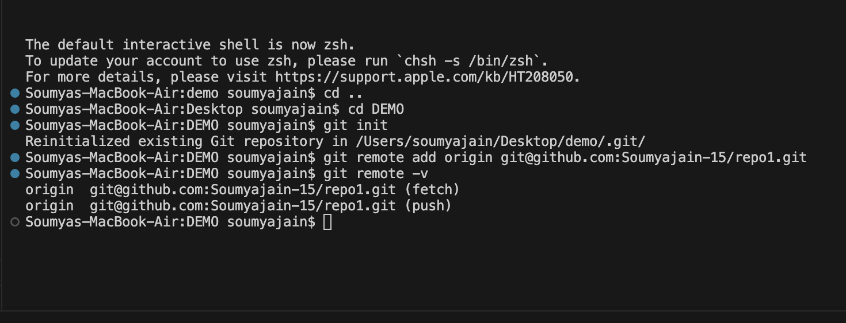
Distributed System
Every developer has a full copy of the repository history locally. This allows offline work and faster operations.
- Speed & Performance
Git is optimized for speed—commits, branching, and merging are all very fast.
- Branching & Merging
Git supports lightweight, flexible branching and merging, making it ideal for feature development and collaboration.
- Data Integrity
Git uses checksums (SHA-1) to ensure data is not corrupted or altered without detection.
- Open Source & Free
Git is free to use and has a huge community for support and tooling.
- Industry Adoption & Tooling
Tools like GitHub, GitLab, and Bitbucket are built around Git, and it's standard in CI/CD, DevOps, and software engineering workflows.
- Scalability
Git handles projects of all sizes—from small personal projects to the Linux kernel itself.
2. Working with Files and Commits
  - Create a new file, add it to staging and commit it.
  - Modify the file and explore the changes.
  - View the commit history (try with options like --oneline, --graph).
  - Query: What is a SHA hash in Git, and why is it important?
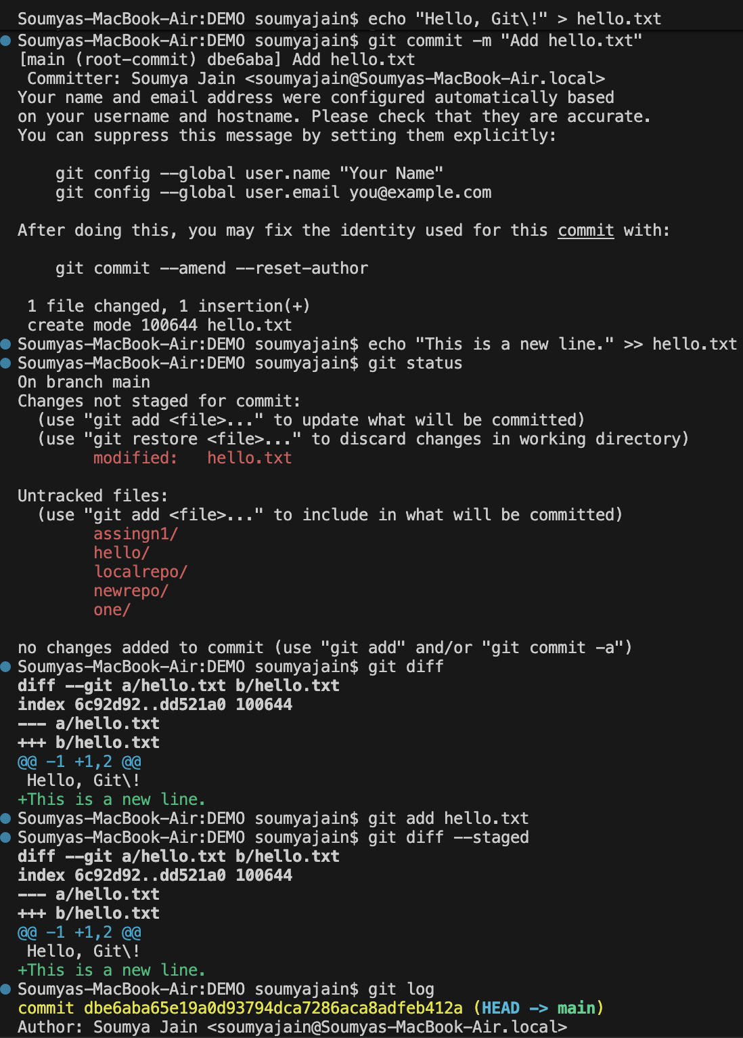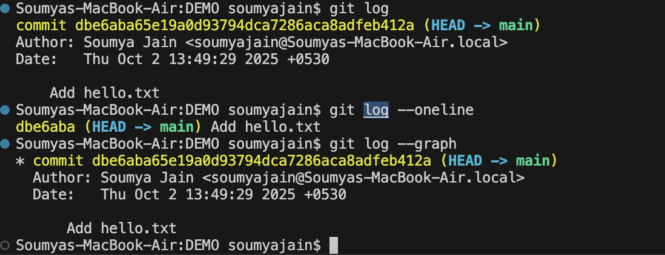
In Git, every commit (and many other objects) is identified by a SHA-1 hash — a 40-character hexadecimal string like:
Uniqueness:
Each SHA hash is a unique fingerprint of a commit. It represents the commit’s contents, author, timestamp, and history.
Integrity:
If any data in the commit changes (even one character), the hash changes. This ensures data integrity—nothing can be secretly changed.
Tracking and Referencing:
You can use the SHA hash to:
- Check out a specific commit
- Revert to it
- Create branches or tags from it
- Share it with others
Security and Trust:
Git relies on SHA hashes to verify that history hasn't been tampered with—this is especially important in distributed development.
3. Understanding Remote Operations

Clone any public repository from GitHub.
Experiment with git fetch to see how it differs from git pull.
Push your local commits to the remote.
Query: What is the key difference between git fetch and git pull?
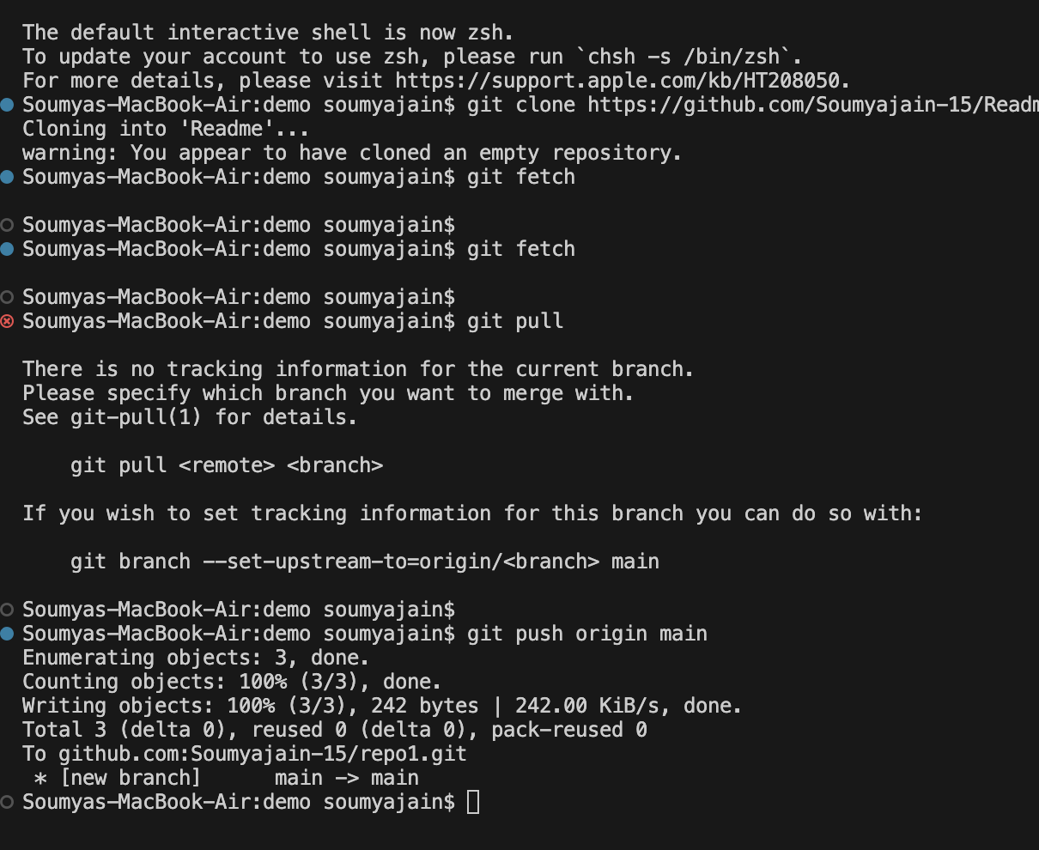
git fetch: Safe way to see what’s new without touching your working branch. Ideal for reviewing before applying changes.
git pull: Fetch + auto-merge. Convenient, but can cause unexpected merge conflicts if not used carefully.
4. Commit Lifecycle & Modification
Make a new change to a file, add it, then undo the staging.
Remove a file from your repository and commit the change.
Make a commit, then change the commit message
Query: How does git reset differ from git rm?
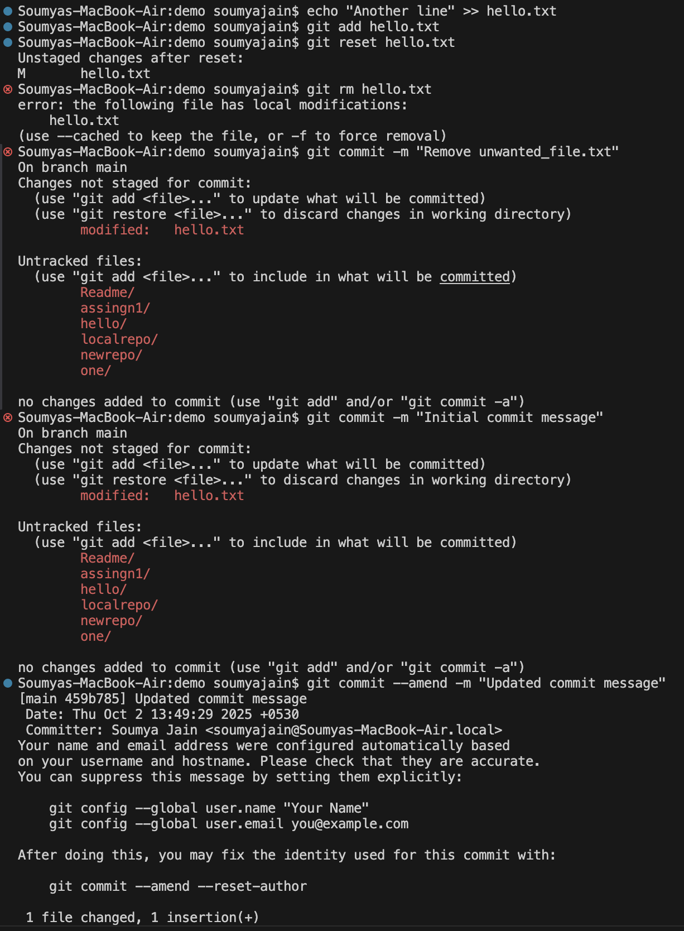
git reset:
➤ "Undo" staging or even commits, without necessarily deleting files (unless --hard is used).
➤ Used to move backward in your Git history or unstage files.
git rm:
➤ Deletes a file from your project and stages that deletion for the next commit.
➤ It’s for when you want to remove a file completely.
5. Advanced Operations
Temporarily save uncommitted changes and then restore them.
Revert a commit.(observe how it creates a new commit instead of deleting history).
Query: How does Git calculate file differences when using commands like git diff? (Hint: HEAD)
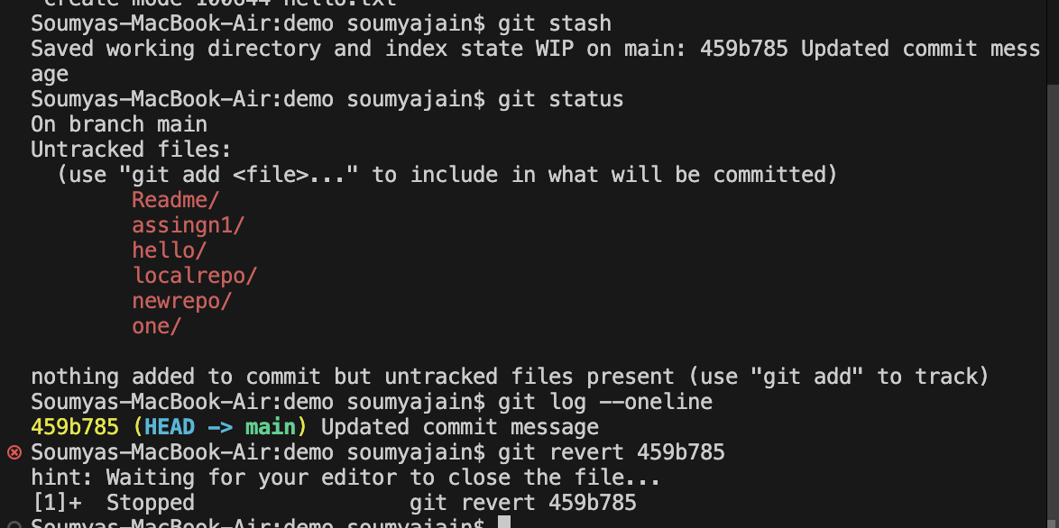
Git calculates file differences by comparing snapshots of file contents between two points—typically between the Working Directory, Staging Area (Index), and the last commit (HEAD). It uses line-by-line comparisons between these snapshots to show what has changed.
HEAD is a pointer to the latest commit in your current branch.
It's Git’s way of saying: “This is the commit you’re currently working from
git diff HEAD

